Database Management with Microsoft Access and Excel 2007

Table of Contents

Section 1 - Using advanced Worksheet functions 5

Names 6

Defining names 6

Defining Names Automatically 7

Creating Names 8

USING NAMES 10

Goto 10

Names in Formulae 11

Applying Names 13

Conditional & Logical Functions 14

IF STATEMENTS 15

Logical Test 17

Value if True / False 18

NESTED IF 19

Statistical If Statements 20

AND, OR, NOT 21

And 21

Or 22

Not 22

Lookup Functions 23

LOOKUP 23

HLOOKUP 26

VLOOKUP 27

NESTED LOOKUPS 28

Goal Seeking and Solving 30

GOAL SEEK 30

Section 2 - Using Excel to Manage Lists 33

Excel Lists 33

List Terminology 34

Row and column content 34

Column labels 34

List size and location 34

Miscellaneous 34

Sorting Data 34

Custom Sorting Options 36

Adding subtotals to a list 38

Examining subtotals 40

Filtering a List 40

Custom criteria 45

Wildcards 47

Turning off AutoFilter 48

Data Form 48

The Data Form Screen 50

Moving 50

Edit or Restore Records 52

Search for Specific Records 52

Entering Search Criteria 52

Finding Ranges of Records 53

Multiple Criteria Using the Data Form 54

Clear Criteria 54

Advanced Filtering 55

Set Criteria 55

Entering Search Criteria 57

Wildcards with Text Criteria 58

Multiple Criteria 58

Checking the Criteria range 59

Calculated Criteria 60

Calculated Criteria using Functions 61

Copying filtered data 62

Unique 63

List Statistics 63

Database Functions 63

Pivot Tables 65

Managing pivot tables 69

Modifying a pivot table 70

Grouping pivot table items 72

Section 1 - Using advanced Worksheet functions

**Objectives**

**By the end of this section you will be able to:**

* Create and use names in workbooks
* Understand and use conditional formulae
* Set up lookup tables and use LOOKUP functions
* Use the Goal SeekNames

When entering formulae or referring to any area on the spreadsheet, it is usual to refer to a "range". For example, B6 is a range reference; B6:B10 is also a range reference. A problem with this sort of reference is that it is not always easy to remember what cells to reference. It may be necessary to write down the range, or select it, which often means wasting time scrolling around the spreadsheet. Instead, Excel offers the chance to name ranges on the spreadsheet, and to use these names to select cells, refer to them in formulae or use them in Database, Chart or Macro commands.

### Defining names

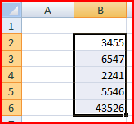

There are a number of ways to set up names on a spreadsheet. A common way is to use the Formulas -> Defined Names -> Define Name menu. In the example, there is a range of revenue figures that could be named "REVENUE";

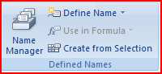

* To name cells:

**Mouse**

1. Select the cells you wish to name.
2. Choose Formulas -> Defined Names -> Define Name. The following dialog box appears;

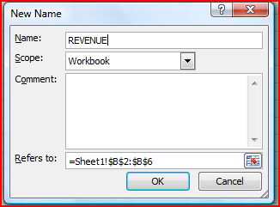

1. The cursor flashes in the **Names** box, and below, in the **Refers to** box, the range reference appears (notice that the range is absolute).
2. To name the cells, simply type a name in the **Names** box and choose OK.

A range can include any selection of cells, not necessarily a contiguous row or column. Names can be up to 255 characters in length, must start with a letter and cannot include spaces. Names are not case-sensitive.

In the example, these cells would be called REVENUE. From now on, any reference to the range B2:C6 can be made with the name REVENUE. Notice that the name box, on the left-hand side of the formula bar now displays the name REVENUE. It will do so whenever cells B2:C6 are selected;

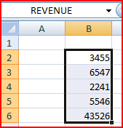

### Defining Names Automatically

Alternatively, cells can be named using text already on the spreadsheet. For instance, in a spreadsheet, a column heading may have already been entered in cell C1 called EXPENSES. This text can be used to name the cells below.

* To define a name automatically:

Mouse

1. Select cells C2:C6 and choose Insert -> Name -> Define.

The dialog box will automatically suggest the name EXPENSES because it is entered in the cell above the selected cells;

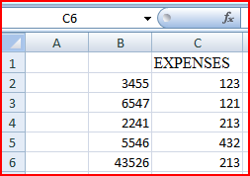   
 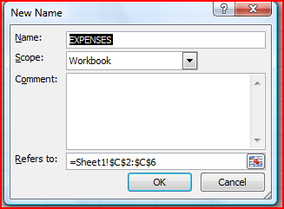

1. Choose OK and, again, the name appears in the Name box on the formula bar.

This procedure works equally well with text entered to the left of a row of data. For example, figures in cells B10:E10 can be named with the text in cell A10;

### Creating Names

If appropriate names are already on the spreadsheet, Formulas -> Defined Names -> Create Names from Selection can be used as an alternative to Define Name. This command is particularly useful for creating several names at once;

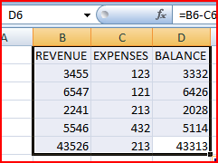

The above spreadsheet contains column headings to denote each column figures. All these figures could be named by the appropriate month using Formulas -> Defined Names -> Create Names from Selection. This option requires not just the data to be selected, but the cells containing the names as well.

* To create names:

Mouse

1. Select cells B1:D6, and choose Formulas -> Defined -> Names -> Create Names from Selection. Excel will automatically generate names in the top row of the selection, in other words cells B2:D6 will be named REVENUE, C2:C6 as EXPENSES etc.

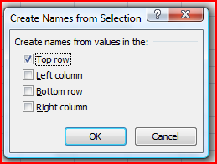

1. To prove that these names have been created, highlight D2:D6 and the new names should be displayed.

The Create Names command can often lead to names intersecting each other. For example, you may also want to name the rows of figures in the spreadsheet by their respective month;

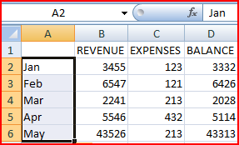

Now the cells containing figures may form part of either the month name. For instance, cell C6 is part of the range May, but also part of EXPENSES.

## 

## USING NAMES

### Goto

The GOTO feature can be used to go to a specific cell address on the spreadsheet. It can also be used in conjunction with names.

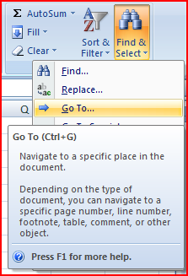

* To goto a name:

**Mouse**

1. Choose Home -> Find & Select -> Go To.

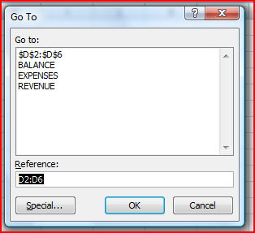

**Or Keyboard**

1. Press [F5]. The following dialog box appears;
2. Click on the name required, then choose OK.

Not only does the cell pointer move to the correct range, but it also selects it. This can be very useful for checking that ranges have been defined correctly, and also for listing all the names on the spreadsheet.

* To move to a cell that belongs to two ranges:

Keyboard

1. Press [F5] and type the first range name in the **Reference** box, then type a space and the second range name.
2. Click OK. The pointer immediately jumps to the correct cell.

### Names in Formulae

Names can be used in any simple formula, as well as any of Excel's built-in functions. Instead of typing cell references or selecting cells, simply type the name or paste the name into the formula.

=SUM(REVENUE)

=AVERAGE(EXPENSES)

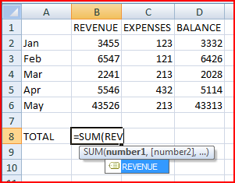

To avoid typing a name, choose from a list and paste in the required name.

* To paste a name into a formula:

Mouse

1. Choose Formulas -> Defined Names -> Use in Formula .

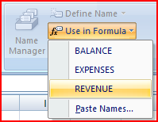

**Or Keyboard**

1. Press [F3]

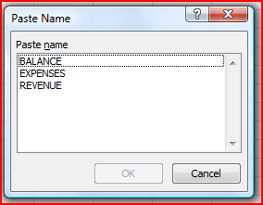

1. Click on the required name and choose OK

To avoid typing altogether, choose Formulas, Function Library, Insert Function, Select a Function, and click on OK. Then choose Formulas, Defined Name, Use in Formula, select the required name and click on OK. Then enter the formula.

### Applying Names

When a cell has already been referred to in a formula, and is then named, the name will not automatically appear in the formula. Similarly, if a cell is referred to by its address rather than its name, the name will not automatically appear. To replace all references with names, the names must be applied.

Suppose a formula is written to sum cells C2:C6;

=SUM(C2:C6)

The formula makes no reference to the range "EXPENSES", even though this range has been named.

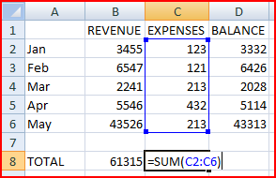

* To replace cell references with range names:

**Mouse**

1. Choose Formulas -> Defined Names -> Apply Names. The following dialog box appears;

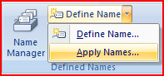

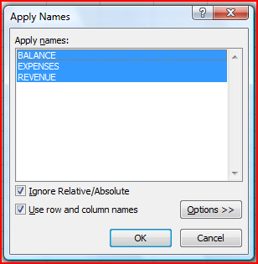

1. Click on the name you want, and choose OK.

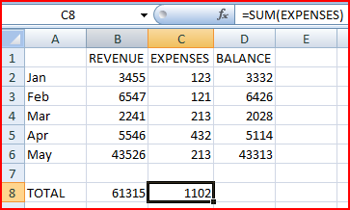

To apply other names at the same time, use [Ctrl] and click on the required names. The formula will now show the range names instead of the cell references.

The Apply Names command works throughout the spreadsheet, so wherever the cell reference to the name you chose appeared, the name is now in its place.

## Conditional & Logical Functions

Excel has a number of logical functions which allow you to set various "conditions" and have data respond to them. For example, you may only want a certain calculation performed or piece of text displayed if certain conditions are met. The functions used to produce this type of analysis are found in the Insert, Function menu, under the heading LOGICAL.

### IF STATEMENTS

The IF function is used to analyse data, test whether or not it meets certain conditions and then act upon its decision. The formula can be entered either by typing it or by pasting it from the Formula, Paste Function box. Typically, the IF statement is accompanied by three arguments enclosed in one set of parentheses; the condition to be met (logical_test); the action to be performed if that condition is true (value_if_true); the action to be performed if false (value_if_false). Each of these is separated by a comma, as shown;

=IF( logical_test , value_if_true , value_if_false)

* To view IF function syntax:

Mouse

1. Click the Formulas -> Function Library -> Insert Function menu.
2. From the resulting dialog box, click on the LOGICAL category on the pull down menu and the IF function below.

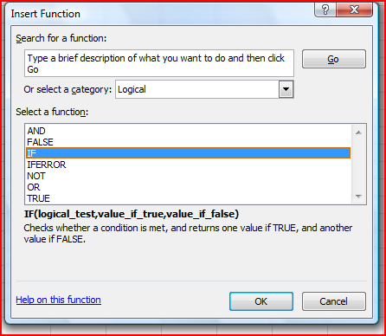

1. The three arguments can be seen at the bottom of the screen;

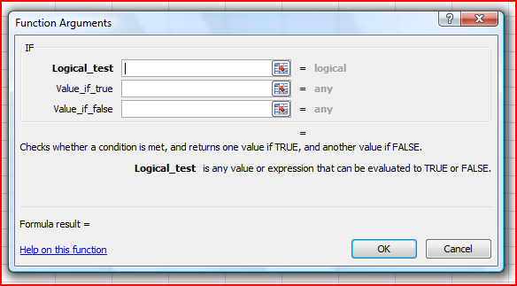

1. Put the follow data into the cells.

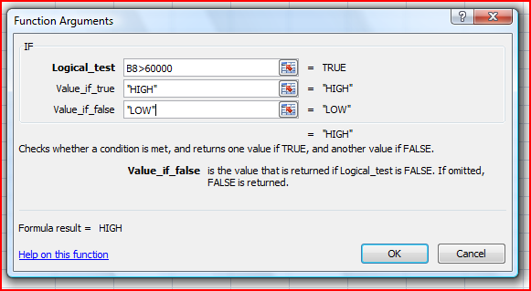

1. Click OK. You should see the result there.

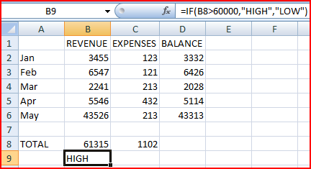

### Logical Test

This part of the IF statement is the "condition", or test. You may want to test to see if a cell is a certain value, or to compare two cells. In these cases, symbols called LOGICAL OPERATORS are useful;

|  |  |
| --- | --- |
| > | greater than |
| < | less than |
| > = | greater than or equal to |
| < = | less than or equal to |
| = | equal to |
| < > | not equal to |

Therefore, a typical logical test might be B8 > C8, testing whether or not the value contained in cell B8 of the spreadsheet is greater than the value in cell C8. Names can also be included in the logical test, so if cells B8 and C8 were respectively named REVENUETOTAL and EXPENSESTOTAL, the logical test would read REVENUETOTAL > EXPENSESTOTAL. Another type of logical test could include text strings. If you want to check a cell to see if it contains text, that text string must be included in quotation marks. For example, cell A1 could be tested for the word Jan as follows; A1="Jan".

It should be noted that Excel's logic is, at times, brutally precise. In the above example, the logical test is that sales should be greater than target. If REVENUETOTAL are equal to EXPENSESTOTAL, the IF statement will return the false value. To make the logical test more flexible, it would be advisable to use the operator > = to indicate "meeting or exceeding".

### Value if True / False

Provided that you remember that TRUE value always precedes FALSE value, these two values can be almost anything. If desired, a simple number could be returned, a calculation performed, or even a piece of text entered. Also, the type of data entered can vary depending on whether it is a true or false result. You may want a calculation if the logical test is true, but a message displayed if false. (Remember that text to be included in functions should be enclosed in quotes).

Taking the same logical test mentioned above, if the sales figure meets or exceeds the target, a BONUS is calculated (e.g. 2% of sales). If not, no bonus is calculated so a value of zero is returned. The IF statement in column D of the example reads as follows;

=IF(B2>=10000,B2*2%,0)

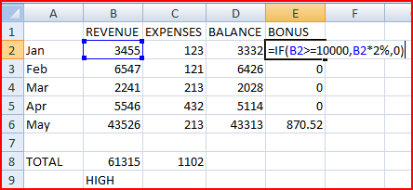

You may, alternatively, want to see a message saying "NO BONUS". In this case, the true value will remain the same and the false value will be the text string "NO BONUS";

=IF(B2>10000, B2*2%, "NO BONUS")

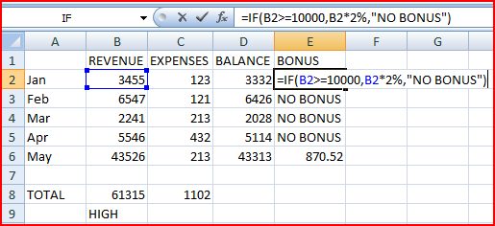

A particularly common use of IF statements is to produce "ratings" or "comments" on figures in a spreadsheet. For this, both the true and false values are text strings. For example, if a sales figure exceeds a certain amount, a rating of "BONUS" is returned, otherwise the rating is "NO BONUS";

=IF(B2>10000, "BONUS", "NO BONUS")

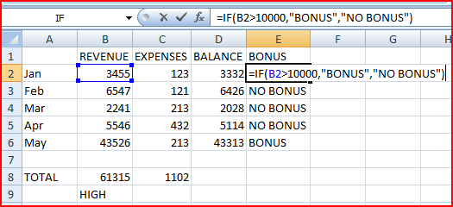

### NESTED IF

When you need to have more than one condition and more than two possible outcomes, a NESTED IF is required. This is based on the same principle as a normal IF statement, but involves "nesting" a secondary formula inside the main one. The secondary IF forms the FALSE part of the main statement, as follows;

**=IF(1st logic test , 1st true value ,** *IF(2nd logic test , 2nd true value , false value)***)**

Only if both logic tests are found to be false will the false value be returned. Notice that there are two sets of parentheses, as there are two separate IF statements. This process can be enlarged to include more conditions and more eventualities - up to seven IFs can be nested within the main statement. However, care must be taken to ensure that the correct number of parentheses are added.

In the example, sales staff could now receive one of three possible ratings ;

=IF(B2>3000, IF(B2>10000, "EXTRA BONUS", "STANDARD BONUS"), "NO BONUS")

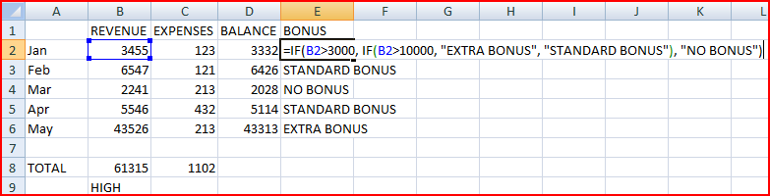

### Statistical If Statements

A very useful technique is to display text or perform calculations only if a cell is the maximum or minimum of a range. In this case the logical test will contain a nested statistical function (such as MAX or MIN). If, for example, we do not need to show "NO BONUS" if there is no bonus. We can just leave it blank.

=IF(B2>3000, IF(B2>10000, "EXTRA BONUS", "STANDARD BONUS"), "")

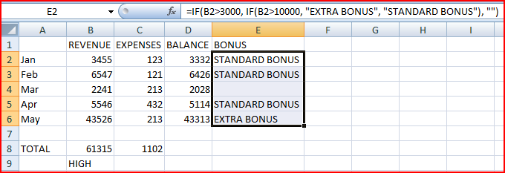

## AND, OR, NOT

Rather than create large and unwieldy formulae involving multiple IF statements, the AND, OR and NOT functions can be used to group logical tests or "conditions" together. These three functions can be used on their own, but in that case they will only return the values "TRUE" or "FALSE". As these two values are not particularly meaningful on a spreadsheet, it is much more useful to combine the AND, OR and NOT functions within an IF statement. This way, you can ask for calculations to be performed or other text messages to appear as a result.

### And

This function is a logical test to see if all conditions are true. If this is the case, the value "TRUE" is returned. If any of the arguments in the AND statement are found to be false, the whole statement produces the value "FALSE". This function is particularly useful as a check to make sure that all conditions you set are met.

Arguments are entered in the AND statement in parentheses, separated by commas, and there is a maximum of 30 arguments to one AND statement. The following example checks that two cells, B2 are both greater than 100 and C2 is less than 300.

=AND(B2>5000,C2<300)

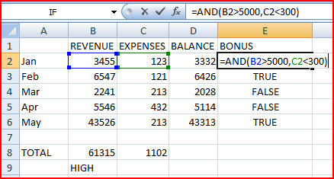

If either one of these two cells contains a false value, the result of the AND statement is "FALSE". This can now be wrapped inside an IF function to produce a more meaningful result. You may want to add the two figures together if they are both correct, or display a message indicating that they are not high enough.

=IF(AND(B2>5000,C2<300), "OK", "FAIL")

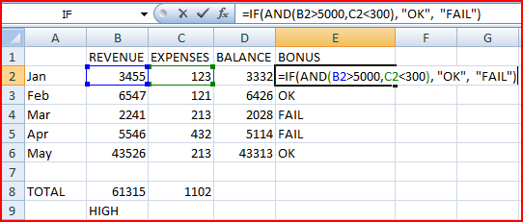

### Or

This function is a logical test to see if one or more conditions are true. If this is the case, the value "TRUE" is returned. If just one of the arguments in the OR statement is found to be true, the whole statement produces the value "TRUE". Only when all arguments are false will the value "FALSE" be returned. This function is particularly useful as a check to make sure that at least one of the conditions you set is met.

=IF(OR(B2>5000,C2<300), "OK", "FAIL")

In the above formula, only one of the numbers in cells B2 or C2 is correct. The message will display OK.

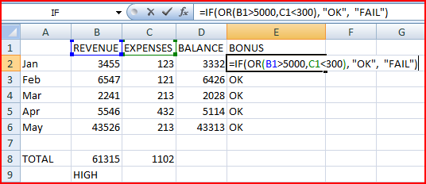

### Not

NOT checks to see if the argument is false. If so, the value "TRUE" is returned. It is best to use NOT as a "provided this is not the case" function. In other words, so long as the argument is false, the overall statement is true. In the example, the cell contents of B2 is found to greater than 5000. If B2 is found to less than 5000, the message "FAIL" is displayed;

=IF(NOT(B2>5000), "OK","FAIL")

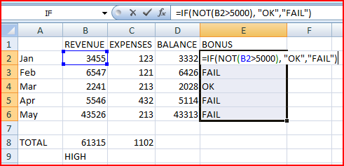

## Lookup Functions

As already mentioned, Excel can produce varying results in a cell, depending on conditions set by you. For example, if numbers are above or below certain limits, different calculations will be performed and text messages displayed. The usual method for constructing this sort of analysis is using the IF function. However, as already demonstrated, this can become large and unwieldy when you want multiple conditions and many possible outcomes. To begin with, Excel can only nest seven IF clauses in a main IF statement, whereas you may want more than eight logical tests or "scenarios". To achieve this, Excel provides some LOOKUP functions. These functions allow you to create formulae which examine large amounts of data and find information which matches or approximates to certain conditions. They are simpler to construct than nested IFs and can produce many more varied results.

### LOOKUP

Before you actually start to use the various LOOKUP functions, it is worth learning the terms that you will come across, what they mean and the syntax of the function arguments.

**Vector Lookup**

A vector is a series of data that only occupies one row or column. LOOKUP will look through this row or column to find a specific value. When the value is found, a corresponding "result" in the adjacent row or column is returned. For example, column D of a spreadsheet may contain figures, and the adjacent column E contain corresponding text. LOOKUP will search for the requested figure in column D and return the corresponding text from column E.

The syntax for LOOKUP is as follows;

=LOOKUP( lookup_value , lookup_vector , result_vector )

The lookup_value represents the number or text entry to look for; the lookup_vector is the area in which to search for the lookup_value; the result_vector is the adjacent row or column where the corresponding value or text is to be found.

It is essential that data in the lookup vector is placed in ascending order, i.e. numbers from lowest to highest, text from A to Z. If this is not done, the LOOKUP function may return the wrong result.

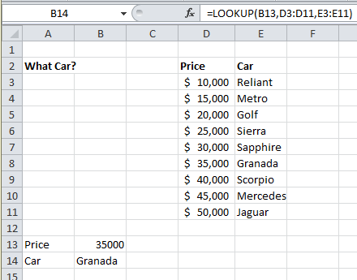

In the diagram, column D contains varying salaries, against which there is a company car in column E which corresponds to each price. For example, a $20000 price gets a Golf, a $25000 price gets a Sierra. A LOOKUP formula can be used to return whatever car is appropriate to a price figure that is entered. In this case, the lookup_value is the cell where the price is entered (B13), the lookup_vector is the price column (D3:D11), and the result_vector is the car column (E3:E11). Hence the formula;

=LOOKUP(B13,D3:D11,E3:E11)

Typing 40000 in cell B13 will set the lookup_value. LOOKUP will search through the lookup_vector to find the matching price, and return the appropriate car from the result_vector, which in this case is Mercedes.

Alternatively, the formula could be simplified and cell references avoided by using Formula, Define Name to give appropriate range names. Call B13 Price, D3:D11 Salaries and E3:E11 Cars. The LOOKUP formula could then be simplified to;

=LOOKUP(Price,Salaries,Cars)

One of the advantages of the LOOKUP function is that if the exact lookup_value is not found, it will approximate to the nearest figure below the requested value. For instance, if a user enters a Price of 23000, there is no figure in the Salaries range which matches this. However, the nearest price below 23000 is 20030, so the corresponding car is returned, which is a Golf. This technique is very useful when the lookup_vector indicates grades or "bands". In this case, anyone in the price "band" between 20000 and 24999 gets a Golf. Only when their price meets or exceeds 25000 do they get a Sierra.

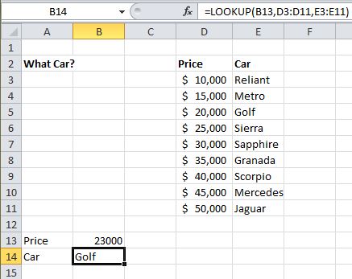

There may be occasions where the lookup_value is below the lowest value in the vector. In this case the #N/A message is displayed.

**To insert a lookup function:**

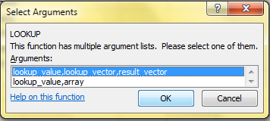

Mouse

1. Click the Formulas -> Function Library -> Insert Function menu.
2. From the resulting dialog box, click on the LOOKUP & REFERENCE category on the pull down menu and the LOOKUP function below.
3. When OK is chosen, another dialog box appears displaying the two versions of LOOKUP. There are two syntax forms; the first is the "array" and the second the "vector".

The second of these forms, the "vector" LOOKUP is by far the most useful, and it is recommended that you only use this form.

### HLOOKUP

The horizontal LOOKUP function (HLOOKUP) can be used not just on a "vector" (single column or row of data), but on an "array" (multiple rows and columns). HLOOKUP searches for a specified value horizontally along the top row of an array. When the value is found, HLOOKUP searches down to a specified row and enters the value of the cell. This is useful when data is arranged in a large tabular format, and it would be difficult for you to read across columns and then down to the appropriate cell. HLOOKUP will do this automatically.

The syntax for HLOOKUP is;

=HLOOKUP( lookup_value , table_array , row_index_number)

The lookup_value is, as before, a number, text string or cell reference which is the value to be found along the top row of the data; the table_array is the cell references (or range name) of the entire table of data; the row_index_number represents the row from which the result is required. This must be a number, e.g. 4 instructs HLOOKUP to extract a value from row 4 of the table_array.

It is important to remember that data in the array must be in ascending order. With a simple LOOKUP function, only one column or row of data, referred to as a vector, is required. HLOOKUP uses an array (i.e. more than one column or row of data). Therefore, as HLOOKUP searches horizontally (i.e. across the array), data in the first row must be in ascending order, i.e. numbers from lowest to highest, text from A to Z. As with LOOKUP, if this rule is ignored, HLOOKUP will return the wrong value.

As an example, a user may have a spreadsheet which displays various different rates of interest for a range of amounts over different time periods;

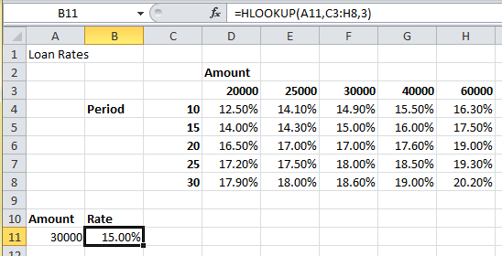

Whatever the amount a customer wants to borrow, he may pay up to five different rates of interest depending on whether the loan is over 10, 15 or more years. The HLOOKUP function will find a specific amount, then move down the array to find the appropriate interest rate for the required time period.

Designate cell A11 as the cell to hold the amount, i.e. the lookup_value; cells C3:H8 are the table_array; the row_index_number will be 2 if a customer wants the loan over 10 years, 3 if he wants the loan over 15 years, and so on. Cell B11 holds this formula;

=HLOOKUP(A11,C3:H8,3)

The above formula looks along the top row of the array for the value in cell A11 (30000). It then moves down to row 3 and returns the value 15.00%, which is the correct interest rate for a $30000 loan over 15 years. (Range names could be used here to simplify the formula).

As with the LOOKUP function, the advantage of HLOOOKUP is that it does not necessarily have to find the exact lookup_value. If, for example, you wanted to find out what interest rate is applicable to a $28000 loan, the figure 28000 can be entered in the lookup_value cell (A11) and the rate 14.30% appears. As before, Excel has looked for the value in the array closest to, but lower than, the lookup_value.

### VLOOKUP

The VLOOKUP function works on the same principle as HLOOKUP, but instead of searching horizontally, VLOOKUP searches vertically. VLOOKUP searches for a specified value vertically down the first column of an array. When the value is found, VLOOKUP searches across to a specified column and enters the value of the cell. The syntax for the VLOOKUP function follows the same pattern as HLOOKUP, except that instead of specifying a row index number, you would specify a column index number to instruct VLOOKUP to move across to a specific column in the array where the required value is to be found.

=VLOOKUP( lookup_value , table_array , col_index_number )

In the case of VLOOKUP, data in the first column of the array should be in ascending order, as VLOOKUP searches down this column for the lookup_value.

In the same spreadsheet as before, a VLOOKUP formula could be used to search for a specific time period, then return the appropriate rate for a fixed amount. In the following example, a time period is entered in cell A14 and in B14 the VLOOKUP formula is contained;

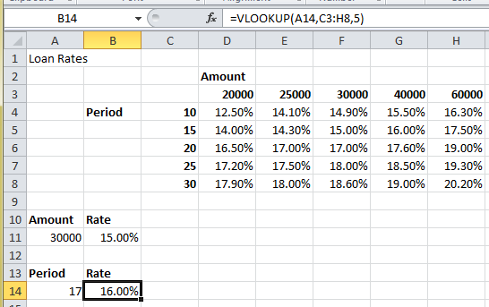

Cell B14 holds this formula;

=VLOOKUP(A14,C3:H8,5)

The cell A14 is the lookup_value (time period), the table_array is as before, and for this example rates are looked up for a loan of $40000, hence the column_index_number 5. By changing the value of cell A14, the appropriate rate for that time period is returned. Where the specific lookup_value is not found, VLOOKUP works in the same way as HLOOKUP. In other words, the nearest value in the array that is less than the lookup_value will be returned. So, a $40000 loan over 17 years would return an interest rate of 16.00%.

### NESTED LOOKUPS

One of the limitations of the horizontal and vertical LOOKUP functions is that for every lookup_value changed, the column or row index number stays constant. Using our example, the HLOOKUP will search for any amount, but always for the same time period. Conversely, the VLOOKUP will search for any time period, but always for the same amount. In both cases, if you want to alter the time period and the amount the formula must be edited to alter the column or row index number.

There is, however, a technique whereby one LOOKUP function is "nested" within another. This looks up one value, which will then be used in a second LOOKUP formula as a column or row index number. Using this technique allows you to, say, enter a time period and an amount and see the correct interest rate.

Because nested LOOKUPs have more than one lookup_value, more than one array is needed. This second array should consist of the column or row numbers to be used in the LOOKUP formula. The example shows our main interest rates spreadsheet, with an additional two columns of data;

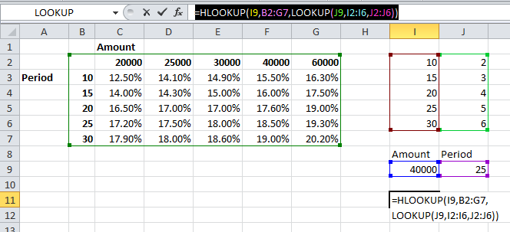

Column J contains all the same time periods as column C, but alongside this are numbers 2 to 6, indicating the row_index_number to be returned for the appropriate time period. To look up this value, use a simple vector LOOKUP formula, where J9 is the required time period, I2:I6 is the lookup_vector and J2:J6 is the result_vector;

=LOOKUP(J9,I2:I6,J2:J6)

Notice there is no equals sign, because this formula is not being entered in a cell of its own. The formula will return a value between 2 and 6 which will be used as a row_index_number in a HLOOKUP formula. This HLOOKUP will look in the main interest rate table for an amount typed in by you, and will respond to the row_index_number returned from the nested LOOKUP formula. The cells I9and J9 hold the amount and time period to be typed in by you, and the entire nested HLOOKUP, typed in I11, is as follows;

=HLOOKUP(I9,B2:G7,LOOKUP(J9,I2:I6,J2:J6))

In the example, the time period 25 is vertically looked up in column J and the corresponding value 5 is returned. Also, the amount 40000 is horizontally looked up in the main table, with a row_index_number of 5. The end result is an interest rate of 18.50%. Simply by changing cells I9 and J9, the correct interest rate is always returned for the amount and period typed in.

## Goal Seeking and Solving

Excel has a number of ways of altering conditions on the spreadsheet and making formulae produce whatever result is requested. Excel can also forecast what conditions on the spreadsheet would be needed to optimise the result of a formula. For instance, there may be a profits figure that needs to be kept as high as possible, a costs figure that needs to be kept to a minimum, or a budget constraint that has to equal a certain figure exactly. Usually, these figures are formulae that depend on a great many other variables on the spreadsheet. Therefore, you would have to do an awful lot of trial-and-error analysis to obtain the desired result. Excel can, however, perform this analysis very quickly to obtain optimum results. The Goal Seek command can be used to make a formula achieve a certain value by altering just one variable. The Solver can be used for more painstaking analysis where many variables could be adjusted to reach a desired result. The Solver can be used to not only obtain a specific value, but to maximise or minimise the result of a formula (e.g. maximise profits or minimise costs).

### GOAL SEEK

The Goal Seek command is used to bring one formula to a specific value. It does this by changing one of the cells that is referenced by the formula. Goal Seek asks for a cell reference that contains a formula (the Set cell). It also asks for a value, which is the figure you want the cell to equal. Finally, Goal Seek asks for a cell to alter in order to take the Set cell to the required value.

In the example spreadsheet, cell B8 contains a formula that sums advertising and payroll costs. Cell B10 contains a profits formula based on the revenue figure, minus the total costs.

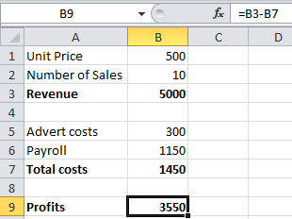

A user may want to see how a profit of 4000 can be achieved by altering payroll costs.

* To launch the Goal seeker:

Mouse

1. Click on the cell whose value you wish to set. (The Set cell must contain a formula). We want to change the Profits so we choose B9 to start.

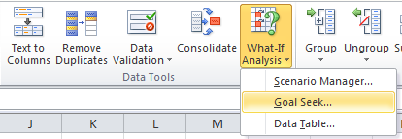

1. Click the Data -> Data Tools -> What-If Analysis -> Goal Seek, and the following dialog box appears:

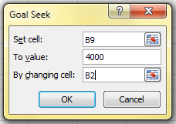

The Goal Seek command automatically suggests the active cell as the Set cell. This can be overtyped with a new cell reference or you may click on the appropriate cell on the spreadsheet.

1. Now enter the desired value this formula should reach. Click inside the TO VALUE box and type in the value you want your selected formula to equal. We want to set it to 4000.
2. Finally, click inside the BY CHANGING CELL box and either type or click on the cell whose value can be changed to achieve the desired result. We want to change the number of sales. So we set it to B2.
3. Click the OK button and the spreadsheet will alter the cell to a value sufficient for the formula to reach your goal. Goal Seek also informs you that the goal was achieved;

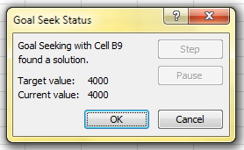

1. You now have the choice of accepting the revised spreadsheet, or returning to the previous values. Click OK to keep the changes, or Cancel to restore previous values.

Goal Seek can be used repeatedly in this way to see how revenue or other costs could be used to influence the final profits. Simply repeat the above process and alter the changing cell reference.

The changing cell must contain a value, not a formula. For example, if you tried to alter profits by changing total costs, this cell contains a formula and Goal Seek will not accept it as a changing cell. Only the advertising costs or the payroll cells can be used as changing cells.

Goal Seek will only accept one cell reference as the changing cell, but names are acceptable. For instance, if a user had named either cells B5 or B6 as "Advert_costs" or "Payroll" respectively, these names could be typed in the BY CHANGING CELL box. For goal-seeking with more than one changing cell, use the Solver.

# Section 2 - Using Excel to Manage Lists

Objectives

By the end of this section you will be able to:

* Set up an Excel list
* Sort the list
* Create list subtotals
* Add, edit and delete list items using the data form
* Use AutoFilter to find specific list data
* Use the Advanced filtering tools
* Analyse list data with data and pivot tables

## Excel Lists

Although Excel's primary function is as a Spreadsheet, it can also be used for a number of list operations. It is possible to store, and manipulate information (customer records, staff records, or stock inventories for example) on an Excel worksheet, organise it in different ways, and "query" the list to extract information which meets specific, user-defined criteria. The list is effectively treated as a database.

In order to use Excel's database capacity, information must be laid out in rows and columns subject to certain constraints. There are some database terms with which the user should become familiar:

## List Terminology

### Row and column content

The information being stored must be divided up into categories. For example, information on staff might include Firstname, Lastname, and Department. In an Excel List, each category must be entered in a separate column. Do not mix text and numbers in a column – the data must belong to the same category of information and therefore should be the same data type. Do not use spaces in front of column entries, use alignment buttons instead if you need to move data away from the column edges.

### Column labels

This is the title at the top of each column, describing the category of information which it contains. Each label name must be unique and must be made up of text rather than numbers or calculations. The column names must appear directly above the list information - they may not be separated from the rest of the list by a blank row. Format your column labels to distinguish them from the list data.

### List size and location

The List is the whole collection of information, all Fields, Fieldnames and Records and should be laid out as a regular block of data.

* A list can be up to 1,048,576 rows by 16,384 columns.
* Do not place more than one list on a worksheet. If you want more than one list in a workbook, place each list on a separate sheet.
* Leave at least one blank row and one blank column between the list and other data on the worksheet.
* Place additional data diagonally below and to the right of your list. This ensures that data will not be affected when you filter the list.

### Miscellaneous

* Excel does not distinguish between upper and lower case characters in a list, unless you use the Case-sensitive sort option.
* When you use formulae in lists, Excel uses the results of the formulae.

## Sorting Data

Although not confined to database information, the sorting facility in Excel is particularly appropriate for changing the order in which records are listed. Remember to save the file containing the database information prior to sorting.

If you will need to restore the original record order, it is a good idea to include a column of record numbers before sorting the database. This can be achieved simply by adding a column with a suitable heading, and using the fill handle or the data series command to enter consecutive numbers adjacent to each record.

* To perform a single-level sort:

Mouse

1. Select a cell in the list within the column by which you want to sort.
2. Click Home -> Editing -> Sort & Filter -> Sort A to Z or Sort Z to A button from the toolbar.



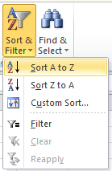

Excel automatically selects the entire list for sorting. It compares the top rows of your list for formatting differences. If there is a difference in the formatting of the top row, Excel identifies that row as column labels and excludes it from the sort. This ensures the column labels will not be sorted with the rest of the data.

* To perform a multi-level sort:

Mouse

1. Select the data to be sorted. This will include all fields and all records, including the field names.

Ensure that all fields are selected, otherwise part of each record will be sorted, while part remains stationary. This could result in situations where a client name is listed beside the wrong address.

1. Choose Home -> Editing -> Sort & Filter -> Custom Sort. The following dialog box will appear in which from which you may specify the Sort fields and the Sort order.

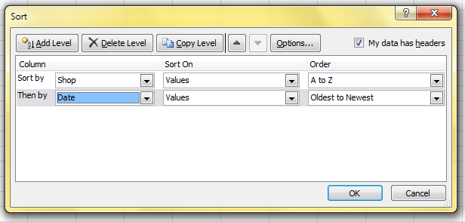

1. From the **Sort By** drop-down list, select the field you want to use as the main sort order. Then select Sort On Values. Finally, select the Ascending or Descending option depending on which order you wish the data sorted in.
2. Specify any sub-sorts using the **Then By** drop-down lists to pick the subsequent fields to sort by when duplicates occur in the main sort field.
3. Click OK.

### Custom Sorting Options

The ascending and descending sort orders rearrange your list by alphabetical, numerical, reverse alphabetical or reverse numerical order. For some types of data, such as months, this may not be the order that you need to use. You can use one of the custom sort orders provided with the Excel program to rearrange your data in chronological order by day of the week or by month.

When sorting by ascending, descending or chronological order is not suitable for the data in a list, you can create a custom sort order. Custom sort orders enable you to give Excel the exact order to rearrange data. Custom sort orders are helpful for data such as Low, Medium, High, where neither alphabetical nor an existing custom sort order will provide the desired results.

* To sort by a custom sort order:

Mouse

1. Select the data to be sorted. This will include all fields and all records, including the field names.
2. Choose Home -> Editing -> Sort & Filter -> Custom Sort. The following dialog box will appear in which from which you may specify the Sort fields and the Sort order.
3. From the **Sort By** drop-down list, select Shop
4. Under Order pull down menu, select the Custom List...

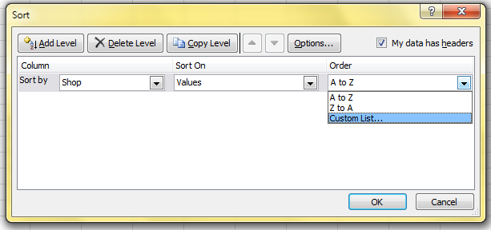

1. In the **Custom Lists** box, verify that New List is selected.
2. In the **List Entries** box, type each unique entry in the order you want to sort the entries. Separate the entries by pressing [ENTER]. (Type HH, TST, Central, CWB, MK)

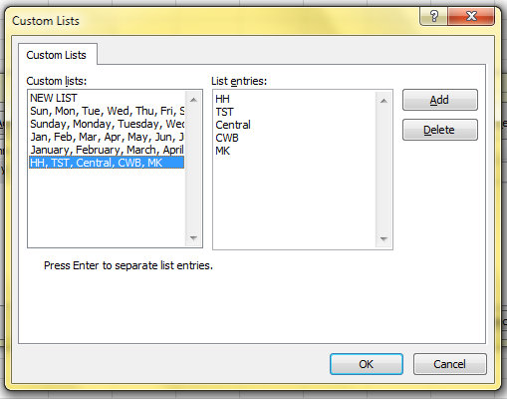

Custom sort orders are saved from the Excel ’2003 program settings and are available for use with all worksheets. You can use a custom list with the AutoFill feature.

## Adding subtotals to a list

Automatic subtotals are useful in summarising the data contained in a list. Subtotals are created by using an Excel summary function such as SUM(), COUNT() or AVERAGE(). To use the subtotals, your data must be organised in a properly designed list and sorted according to the column by which you want to summarise the data.

* To add subtotals to a list:

Mouse

1. Sort the list according to the column by which you want to summarise the data. (just like what you did in last section)
2. Choose Data -> Outline -> Subtotal.

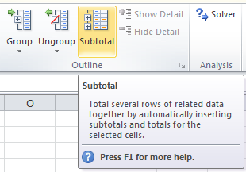

1. From the **At Each Change** In drop-down list, select the field by which you want to summarise the data. (Select Shop)
2. From the **Use Function** drop-down list, select the summary function you want to use to generate the subtotals. (Select Sum)
3. In the **Add Subtotal To** box, check the column to which you want the function to be applied. (Select Amount)

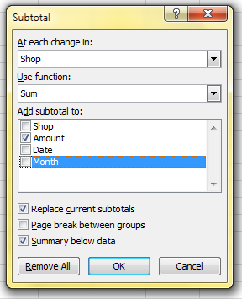

1. If desired, check the options for replacing the current subtotals (if any), inserting a page break for each summary group, and inserting the summary below each group.
2. Click OK.

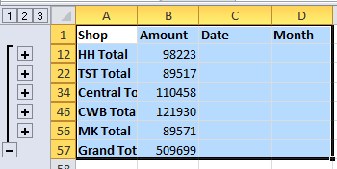

When you use the Data, Subtotals command, it adds its own Grand Total, so you should not use the SUM() function in your list. If you use the Data, Subtotals command, the SUM() function will be inaccurate since it includes the subtotals in the calculation.

* To remove subtotals from a list:

Mouse

1. Select a single cell somewhere within the subtotalled list.
2. Choose Data -> Outline -> Subtotal.
3. Click Remove All and then OK.

### Examining subtotals

When you insert automatic subtotals, Excel creates an outline of your data. The outline enables you to show or hide certain sections of data by clicking on the outline buttons below the Name box on the formula bar. Grand total values are derived from the list data, not the subtotal rows.

## Filtering a List

When you filter a list, you display only the sets of data that meet a certain set of search conditions called *criteria.* The AutoFilter feature enables you to specify those search conditions from the list.

When you use the Data, Filter, AutoFilter command, drop-down list arrows are displayed next to each of the column labels in the list. When you open a drop-down list, a list of all the unique entries for that column is displayed. By selecting one of the entries from the drop-down list, called a *filter criterion* you instruct Excel what to search for. Then Excel filters the list so that only the sets of data that contain the entry you selected will be displayed. When Filter mode is active, arrows for the columns with filter criterion selected appear in blue on the worksheet, row numbers appear in blue, and the status bar displays either the number of rows that meet the criteria, or the text “Filter mode”. The sets of data that do not meet the criteria remain in the list but they are hidden.

If you select a single cell in the list before choosing Data, Filter, AutoFilter, drop-down list arrows are applied to all of the column labels in your list. If you select multiple column labels before choosing Data, Filter, AutoFilter, drop-down list arrows are displayed only for the selected columns, thus restricting which columns you can apply filters to. In either case, the entire list is filtered. Also, you can filter only one list at a time on a worksheet.

* To filter a list using AutoFilter:

Mouse

1. Place the active cell anywhere within your list.
2. Choose Home -> Editing -> Sort & Filter -> Filter. Your list column labels will appear with drop-down list arrows to the right.

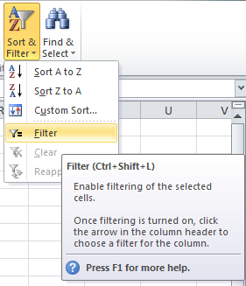

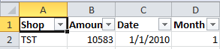

1. Click the drop-down arrow for the column that you want to filter by to display the unique values from that column. Select the value you are filtering for.
2. Repeat step 3 until you have set filter criteria for all columns that you wish to filter by. (select MK and TST only in Column A) (Select Sort Oldest to Newest in column C)

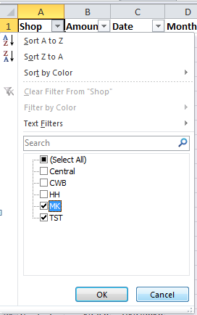

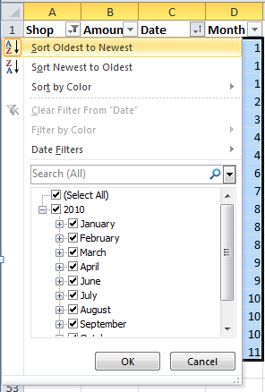

1. The list will show only those rows that match your criteria.

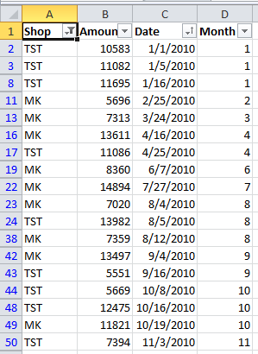

Whilst a filter is active, if you print the worksheet, only visible rows will be output, so you can print out multiple views of your data from an individual list.

* Removing a single column filter:

Mouse

1. You can see which columns have filter criteria active because the drop-down list arrows are blue. Click the drop-down list arrow for the column whose criteria you wish to remove.
2. Check Select All at the top of the list.

OR

1. Click Clear Filter From “Shop”
2. 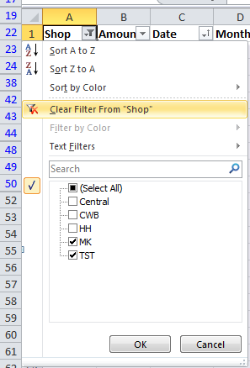

* Removing all column filters:

Mouse

1. Choose Home -> Editing -> Sort & Filter -> Clear.

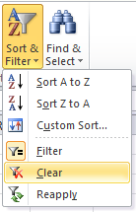

### Custom criteria

When you specify a filter criterion for a column from unique entries listed in the AutoFilter drop-down list, you can only select one filter criterion at a time. The Custom filter criterion enables you to filter a list to display sets of data that contain either of two unique entries in a column. This creates an OR condition. To meet the filter criteria, a set of data must meet either the first filter criterion or the second filter criterion.

You can also use the Custom criterion choice to find values that fall within a range. When you specify custom criteria, select a comparison operator from the drop-down list and then either type in a value or select it from the criteria drop-down list.

When you use custom criteria, you need to understand the comparison operators that Excel offers you. The table below outlines these:

|  |  |
| --- | --- |
| **Operator** | **Meaning** |
| = | Equal to |
| > | Greater than |
| < | Less than |
| >= | Greater than or equal to |
| <= | Less than or equal to |
| <> | Not equal to |

* To specify “either/or” custom criteria:

Mouse

1. Click on the AutoFilter drop-down for the desired column.
2. Select Custom.
3. In the Custom AutoFilter dialog box from the first criteria drop-down list select one of the filter criteria. (The default operator is =).
4. Click on **Or**.
5. From the second operator drop-down list, select a comparison operator.

From the second criteria drop-down list select the other filter criterion.

Click OK. The filtered list shows the sets of data that meet either the first or the second specified criterion for the column.

* Using custom criteria to find a range of values:

Mouse

1. Click the drop-down arrow for the column label whose range of values you want to filter by.

This will typically be numbers or dates

1. Click Custom. From the resulting dialog box, select the comparison operator to control the lower limiting value, for example > or >=.
2. From the first criteria drop-down list, select a value or type the value in.
3. Click OK

**Or**

Choose an upper limiting value by selecting a comparison operator from the second operator drop-down list and selecting a second criterion from the second criteria drop-down list or typing one in. Click OK.

### Wildcards

You can use wildcards to search for text in common within the unique entries, even though the entire entry might not match. For example, searching for all of the sets of data that have entries in the last-name column that begin with “M” might display two Moores (where the entire entry matches) but might also display Madding and Martinez (where the entire entry does not match).

|  |  |  |  |  |
| --- | --- | --- | --- | --- |
| **Wildcard** | **Finds** | | **Example** | |
| * asterisk | Any set of characters that are in the same position as the asterisk | | *.xls finds Filter.xls and sortdata.xls | |
| ? question mark | | Any single character that is in the same position as the ? | | B?t finds Bat, Bit, But and Bet |
| ~ tilde | | A question mark or an asterisk | | Who~? Finds the text “Who?” |

* To filter a list using wildcards:

Mouse

1. With AutoFilter active, select the drop-down list arrow to the right of the column you want to use to filter the data.

Wildcards only work when filtering columns containing text

1. Choose Custom.
2. Ensure that the operator is set to =.
3. Type the pattern of letters you are filtering by with the asterisks and/or question marks inserted in the appropriate positions.
4. Click OK.

### Turning off AutoFilter

When you no longer need to filter your data, you can switch the AutoFilter off in the following way:

* To switch off AutoFilter:

Mouse

1. Choose Data from the menu bar, then Filter.
2. The AutoFilter option on the submenu will appear ticked showing that AutoFilter is currently active. Click AutoFilter to remove the tick and deactivate the AutoFilter.

## Data Form

Once the List area has been defined, you may choose to view and operate on the records via the Excel Data Form. This is a dialog box that enables you to enter, edit or find sets of data. Working with a data form can be a time-saving tool when maintaining data in lists.

* To activate the Data form:

1. Click on a cell within the list.
2. Click on Quick Access Toolbar -> More commands

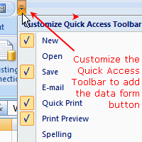

1. Choose All Commands

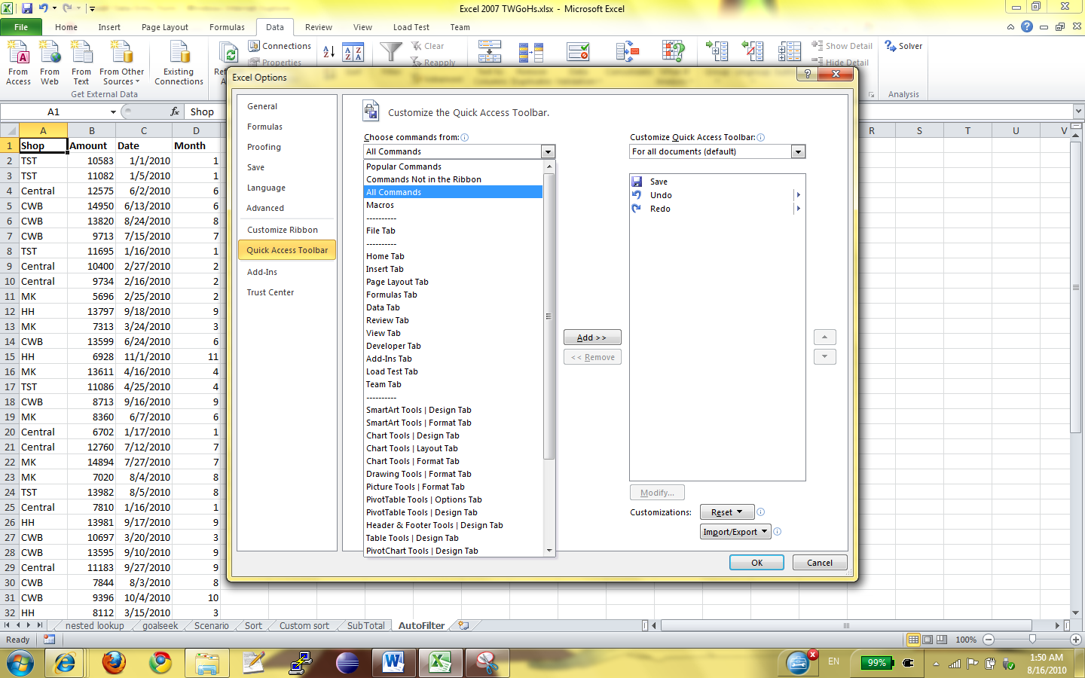

1. Choose Form -> Add>>

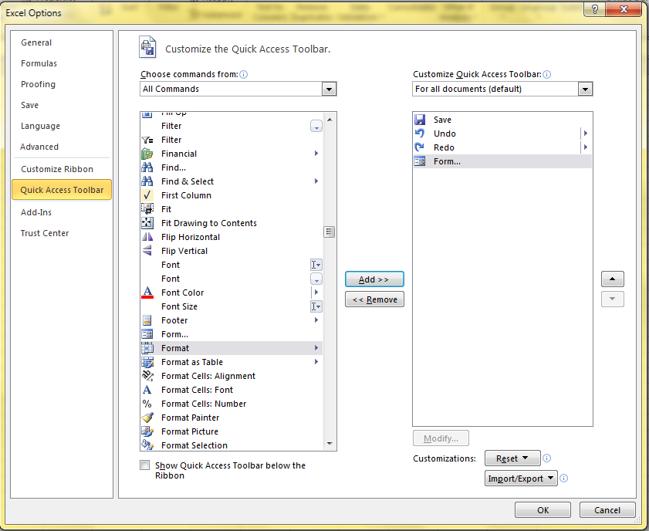

1. Then you can see the form button on the top.



### The Data Form Screen

A dialog box will appear on screen, displaying the name of the worksheet containing the list across the title bar. Each column name will be listed down the left hand side of the dialog box, and the details for one record will be displayed.

### Moving

There is a vertical scrollbar which can be used to move up and down through the available records. The current record number will appear at the top right of the Data Form, and will adjust as you move through the records.

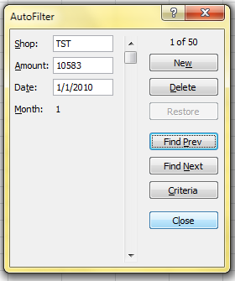

A series of buttons appears down the right hand side of the Data Form. These can be used to perform a number of different operations on the data.

* To add records using the data form:

Mouse

1. Click on the New button to add a new record to the database.
2. The record number display will change to New Record, and the fields beside each fieldname will be cleared, waiting for you to input information.

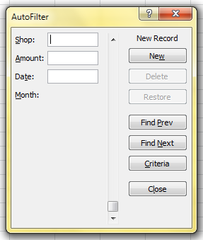

1. Use Tab or [Shift] Tab to move from field to field.

* To delete records using the data form:

Mouse

1. Move to the record you want to delete.
2. Click on the Delete button in order to delete the record currently on display.

This operation cannot be reversed.

### Edit or Restore Records

You may click in any of the text boxes and edit the information it contains. If you click on the Restore button before moving away from the record displayed, the changes will be undone and the original information on that record will be restored.

### Search for Specific Records

It is possible to specify particular field contents and require Excel to identify those records matching your specifications. This can be done using the Criteria button.

### Entering Search Criteria

At the most basic level, either text or numeric data can be entered so that Excel will find those records where the relevant field exactly matches what you have entered. Excel is not case sensitive when matching criteria, so text can be entered in upper or lower case.

Excel will find those records which match the data entered in the criteria range, but will also match any records where the initial letters match the specified data. For example, searching for the first name Rob will find all exact matches, but will also match any records where the first name happens to be Robert or Robin.

When using the Data Form, if you wish to confine the search results to only those records where the first name is Rob, it would be necessary to enter the formula =Rob in the appropriate field in the Criteria form.

|  |  |
| --- | --- |
| Criteria Entered | Results Matched |
| Rob | Rob; Robert; Robin |
| =Rob | Rob |

### Finding Ranges of Records

Relative or Comparison operators such as < or > can be entered with data. For example, <25 entered in a field entitled Age would limit the view to only those persons whose age was less than 25.

|  |  |
| --- | --- |
| Relative Operators | Definition |
| = | Equal to |
| < | Less than |
| <= | Less than or Equal to |
| > | Greater than |
| >= | Greater than or Equal to |
| <> | Not Equal to |

Comparison operators may also be used on fields containing text information. Entering <C in a field entitled Surname would limit the view to only those persons whose name began with either A or B.

Entering the = symbol on its own in a field would allow Excel to find those records where that field was blank. The <> symbol on its own in a field would identify records where that field was not blank.

Date searches may also be carried out using either exact matches or in combination with comparison operators. To find records dated earlier than 1st January 2010, you could enter <2/1/2010.

### Multiple Criteria Using the Data Form

A combination of different specifications may be entered in different fields and Excel will find only those records which meet all specifications. For example, if you enter TST as the Shop, Excel will find only those orders which fulfil the criteria.

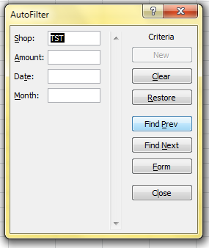

* To find records by setting criteria:

Mouse

1. Click Criteria
2. A blank form will display. Use the [TAB] key to move to the text box for the field where you want to set the criteria and type it in.
3. Click Find Next to jump down to the first matching record in the list. Clicking Find Next will subsequently allow you to move through the matching records one by one until Excel bleeps, signalling there are no more matches. Click Find Previous to jump to matching records in an upwards direction.

### Clear Criteria

When you click the Criteria button Excel offers you a dialog where you can set criteria. Your last criteria will have been stored and remembered and will still be visible in the relevant text boxes.

* To clear criteria:

Mouse

1. Click the Clear button.

* To return to the data form:

Mouse

1. Click on the Form button to return you to the Data Form

## Advanced Filtering

Sometimes, the filter criteria that you specify with AutoFilter will not yield the necessary results. For example, you cannot use AutoFilter to filter a list to display the more complex criteria of two separate AND conditions combined with an OR condition. To do this, you must use the Advanced Filter option. This relies on you setting up and defining a Criteria range on the worksheet where the data to be matched can be entered.

### Set Criteria

The Criteria range usually consists of a copied set of the list column names, and a blank row immediately beneath into which you can type the data to be matched. It is a good idea to copy the column names from the top of the database into the area to be used as a criteria range, as this reduces the chance of there being any discrepancy between the two sets of names.

In fact, not all the column labels need to be included in the criteria range. It could be restricted to only those labels on which you wished to search, and those labels included could be displayed in a different order. Usually, however, the names are copied complete from the top of the list.

* To define the Criteria range:

Mouse

1. Select the copied set of column labels and the blank row immediately beneath them and choose Insert from the menu bar, then Name, Define.
2. Type the word *Criteria* into the name box and press [ENTER].

You do not have to name the cells with the range name **Criteria**, but it will ensure that Excel automatically picks the correct group of cells as the criteria carrying cells whenever you use the Advanced Filter.

* To run an advanced filter:

Mouse

1. Enter criteria in the blank row of the criteria range under the appropriate column label(s).

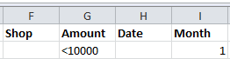

1. Choose Data -> Sort & Filter -> Advanced Filter.

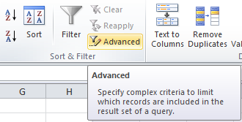

1. Set the Criteria range. (F1:I2)

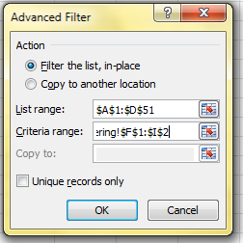

1. Excel will hide the records which do not match the search settings.

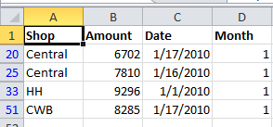

* To remove a filter:

Mouse

1. When finished viewing the results of the Filter operation, choose Data -> Sort & Filter -> Clear.

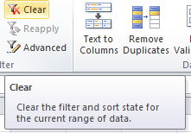

### Entering Search Criteria

At a basic level criteria entered in the Criteria range is subject to the same limitations as were outlined in the Data Form section, but making use of a user defined Criteria range rather than the Criteria section of the Data Form allows more complex searches to be performed.

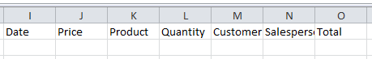

It is important to remember to delete old criteria before applying a new filter. Otherwise the true results of a filter will not be shown. For example, if the first filter is applied with Johnson entered under Surname, and a subsequent filter is carried out for those who work in Finance, it is essential that the Name specification is cleared unless you deliberately wish to confine the filter to those people called Johnson who happen to work in the Finance department.

As with the Data Form, Excel will find records matching text information entered in the Criteria range and records where the initial letters match the specified data. When working with a user defined criteria range, if you wish to confine filter results to only those records where, for example, the first name is Rob, it would be necessary to enter the formula ="=Rob" in the Criteria range under the appropriate column label.

|  |  |
| --- | --- |
| Criteria Entered | Results Matched |
| Rob | Rob; Robert; Robin |
| ="=Rob" | Rob |

### Wildcards with Text Criteria

One variation on searches for text criteria consists of using text Wildcard symbols. In fact Wildcards may be used for searches using the Data Form screen also. The two Wildcard symbols may be familiar to users of other PC systems.

#### The Asterisk

The Asterisk (*) may be substituted for any group of characters. Searching for *Banking would find both Development Banking and Merchant Banking. If no Wildcard symbols are included in the search criteria, Excel usually assumes that there is an asterisk at the end of the specification, so it will match the data specified and any records where the initial data is the same.

#### The Question Mark

The Question Mark (?) may be substituted for any single character. The question mark identifies the position of the wildcard character within the string of text. T?m would find Tim or Tom. ?a would find all records where the second letter in the appropriate field was an A. Once again, Excel will assume that there is an asterisk on the end of the search specification unless otherwise informed. Entering T?m in a Firstname field would find Tim, Tom and Tommy. Use the syntax ="=T?m" to confine the searches to three characters in length.

### Multiple Criteria

Hitherto, the Criteria range has been described as a copied set of field names followed by a blank row, into which you may enter search specifications under the appropriate column names. As with the Data Form criteria screen, you may choose to enter criteria in the blank row under more than one field name. Entering Finance as the department and 7 as the grade for example, would find only those persons who met both criteria.

Multiple criteria on the same row dictates that the first specification AND all other specifications must be met in order for Excel to find the record. (See also use of the AND() function under Calculated Criteria).

#### Using Multiple Rows in the Criteria Range

There may be situations where you wish to find members of either Finance or Infen. In such an instance the Criteria range can be extended to include a second row into which you may enter specifications:

* Extending the criteria range for OR criteria:

Mouse

1. First delete the current *Criteria* range name. Choose Insert from the menu bar, then Name, Define.
2. Select *Criteria* from the names list inside the dialog and click Delete.

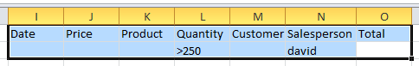

1. Highlight the entire region to be redefined as the Criteria range - i.e. the copied set of Column names and the two rows (or more) immediately below, and choose Insert from the menu bar, then Name, Define.
2. Type the word *Criteria* into the name box and press [ENTER].

Now, entering search specifications in all rows within the range will allow Excel to identify all those records which meet the specifications in either the first OR the second row etc. (See also use of the OR() function under Calculated Criteria).

The Criteria range may be extended to include three or more rows of user defined search criteria if required.

To return to using just one row of user defined information in the Criteria range, select the area to be included and redefine the Criteria range again. This is important because searching for data when a row in the Criteria range has been left blank, will result in Excel finding every record in the database. In effect, you have asked Excel to find all records where the contents of any field can be anything at all.

### Checking the Criteria range

If you are getting surprising results when you filter your data, it may be because your criteria range contains unlabelled cells or extra rows that you thought you had removed from the range.

It is easy to double check the currently defined Criteria range at any time by making use of the range name which Excel applies to it. Using the [F5] function key will result in a dialog box showing all the currently named ranges on the worksheet. Click on the name Criteria and choose OK. The area covered by that name will be highlighted. You may choose to alter the selection and redefine the Criteria range again to adjust it.

### Calculated Criteria

You may also choose to find data subject to calculated criteria rather than exactly matching data or using comparison operators or wildcard characters. This would let you find data that matches the result of a formula, rather than a value that you have entered directly

* To use calculated criteria:

Mouse

1. Include in the Criteria range one column name which is not used in the list - Calc for example.
2. Choose Insert from the menu bar, then Name, Define. Select *Criteria* from the names list and click Delete.
3. Select the column labels (including *Calc* or whatever you have named it) plus at least one row below them depending on whether you need use multiple OR conditions to filter your data.
4. Choose Insert from the menu bar, then Name, Define. Type *Criteria* into the Name box and press [ENTER]

Below the calculated fieldname in the criteria range, you must enter a formula which refers to the cells contained in the first record of the database. The formula must result in a TRUE or FALSE answer.

In the example below, in order to find only those records where the value of an order would increase to over 500 if a 10% increase was applied, the formula shown could be entered in the *Calc* column.

=G2:G51*1.1>500

When entered, the calculated formula displays on the worksheet as TRUE or FALSE depending on the figures contained in the first record of the database to which the formula specifically refers. The underlying formula displays in the formula bar as usual.

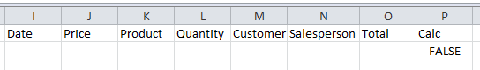

You may use calculated fields to refer to and manipulate cells within the first record of the database, and to refer to cells outside of the database area. For example, the threshold figure of 500 might be held in an input cell outside the database. If this was the case, that cell reference could be included in the calculated search criteria, but the reference to it would need to be absolute or fixed.

### Calculated Criteria using Functions

Some of Excel's Logical Functions are particularly suited to setting Criteria for a list search. Rather than having to extend the criteria range, you can specify criteria as arguments within the AND(), OR() or NOT() functions.

#### =AND()

If there are several specifications, every one of which must be met by all records found, use the AND() function and refer once again to the cells contained in the first record of the database. Text entries must be enclosed in double quotes. The AND() function may contain up to 30 comma separated arguments

Referring to the database in the diagram below, for example, if the Quantity must be greater than or equal to 50, the Product a Widget and the Salesperson David, the calculated function might be set as appears on the Formula bar:

=AND(C2:C51="a15",D2:D51>=50,F2:F51="david")



#### =OR()

Searching for two different entries in the same field would necessitate the use of the OR() function. You may wish to locate all the records where the Customer is either Jones Brothers or Viking Supplies. Obviously the AND() function will be inappropriate, because the customer cannot be both companies simultaneously. Instead, the calculation might be:

=OR(E2:E51="jones brothers",E2:E51="viking supplies")



Excel will find any records where any one of the arguments contained in the OR() function is met. The OR() function may contain up to 30 comma separated logical arguments.

#### =NOT()

The NOT() function can be used to exclude records meeting certain criteria from the find operation. Entering a calculation such as:

=NOT(product="A15")

will allow Excel to find all those records where the Product is anything other than a Gimlet. The NOT() function contains only one argument. It can be combined with other functions, for example:

#### =AND(NOT(product="A15"),quantity<20)

will find all those orders for items other than Gimlets where the Quantity ordered was less than 20.

### Copying filtered data

You can use the Data, Filter, Advanced Filter command to copy the sets of data that meet the criteria in the Criteria range to another location on the worksheet.

* To copy filtered data to another location:

Mouse

1. Set the Criteria range.
2. Place the active cell within the list.
3. Choose Data from the menu bar, then Filter, Advanced Filter.
4. In the resulting dialog box, choose Copy to Another Location.
5. In the Copy To text box, enter a worksheet cell that represents the top left-hand corner of where you would like the results.
6. Click OK.

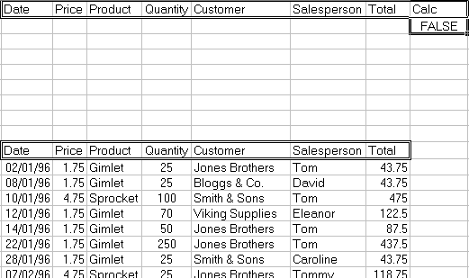

If you want to copy only certain columns from the matching sets of data, enter the column labels exactly as they appear in the list in the location you want to copy to. When you run the filter, set the Copy To range reference to the cells where you have typed the column labels.

Data copied to here

### Unique

There is a check box [] allowing you to select Unique records only. This may be useful if, for example, the Copy To range does not include all the column labels. There may be several records where the Product and Customer are the same. If the Quantity, Date and Salesperson are not included in the Copy To range, this could result in several seemingly identical records being extracted. Checking the Unique records only check box before choosing OK would result in Excel extracting only the first record in each instance.

## List Statistics

There are several Excel functions which are specifically designed to enable you to analyse database information. A selection of these appear in the table below.

## Database Functions

|  |  |
| --- | --- |
| Function | Purpose |
| DCOUNT(Database,Field,Criteria) | To count the number of records in a list which meet specified criteria. This function will only count value cells. |
| DCOUNTA(Database,Field,Criteria) | To count the number of records in a list which meet specified criteria. This function includes text and value cells. |
| DSUM(Database,Field,Criteria) | To add the contents of the chosen field in a list, subject to any specified criteria. |
| DMIN(Database,Field,Criteria) | To find the minimum value in the chosen field in a list, subject to any specified criteria. |
| DMAX(Database,Field,Criteria) | To find the maximum value in the chosen field in a list, subject to any specified criteria. |
| DAVERAGE(Database,Field,Criteria) | To find the average value of the chosen field in a list, subject to any specified criteria. |
| DGET(Database,Field,Criteria) | To return the contents of the chosen field subject to any specified criteria. This function is only valid where a single record meets the criteria set. |
| DPRODUCT(Database,Field,Criteria) | To multiply the contents of the chosen field in a list, subject to any specified criteria. |

In all cases, if the Criteria range is blank, these functions will apply to the entire list area. Once data is entered in the Criteria range, the results of the Database functions will adjust to reflect only those records meeting the criteria.

The arguments for all of these functions are identical, and the easiest way to incorporate them into a worksheet is by using the Paste Function dialog.

* To enter a database function on the worksheet:

Mouse

1. Click the Function Wizard button from the standard toolbar.
2. In the function category list, select Database.
3. From the function name list choose the database function you require: e.g.=DMAX()
4. Enter the three arguments, list range, field name and criteria range.
5. Press [ENTER]

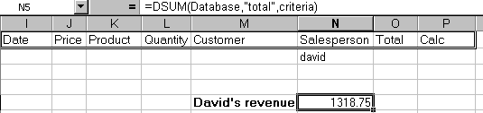

If you have assigned the range name **Database** to your list area and **Criteria** to your criteria range you use [F3] to paste the names in.

The field may be entered as a number or as text. Obviously, if the field on which the function is to operate is the fifth column within the database, you could enter the number 5 as the field argument. Alternatively, the field name could be entered as text, in which case it would need to be enclosed in double quotes:

=DMAX(database,"Price",criteria)

In the above example, the formula shown on the formula bar above has been entered into the cell to the right of the label “David’s revenue”. This formula sums the total column but only where the order was placed through the salesperson David. All the database functions look at what has been entered in the criteria range in order to give their results.

## Pivot Tables

A pivot table can summarise large amounts of data using specified calculations and formats. It is called a pivot table because the headings can be rotated around the data to view or summarise it in different ways.

The source data can be:

* An Excel worksheet database/list or any range that has labelled columns.
* A collection of ranges to be consolidated. The ranges must contain both labelled rows and columns.
* A database file created in an external application such as Access or Dbase.

The data in a pivot table cannot be changed as it is the summary of other data. The data itself can be changed and the pivot table recalculated. The pivot table can be reformatted.

* To create a pivot table:

Mouse

1. Select a cell within your list. (A1:B51)
2. Choose Insert -> PivotTable -> Pivot Table report.

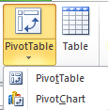

1. The range will be put to the box.

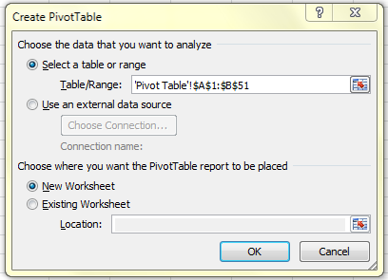

1. Pivot Table Field List pane will be shown on the right hand side.

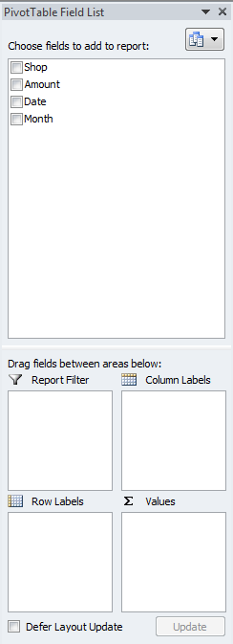

1. This screen will enable you to define your Pivot Table. Drag and drop the field buttons for the Row Labels, Columns Label and Values. Each Row Labels, Columns Label and Values can have more than one label.
2. Drag Shop to the Row Labels, Month to the column Labels, Amount to the Values.

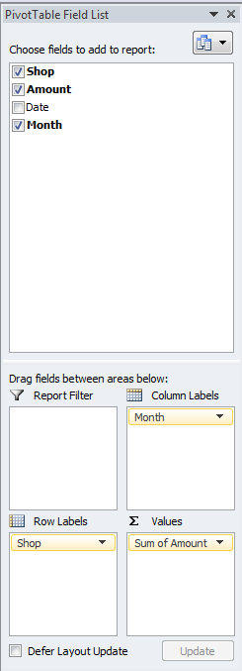

1. Excel assumes SUM as the calculation method for numeric fields and COUNT for non-numeric fields. You can change the calculation method by clicking the pull down menu in the Values.

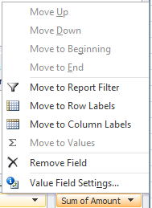

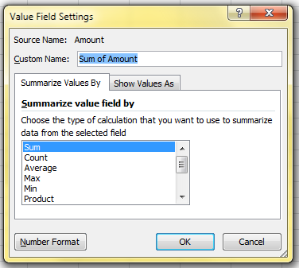

### Managing pivot tables

When data is changed in the pivot table source list, the pivot table does not automatically recalculate.

* To refresh a pivot table:

Mouse

1. Select any cell in the pivot table to be refreshed.
2. Choose PivotTable tools -> Options -> Data -> Refresh

Or

Right click any cells and choose Refresh

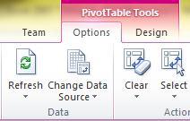

### Modifying a pivot table

Adding or deleting fields can modify a pivot table.

* To swap pivot table row and column headings:

Mouse

1. Using the Pivot Table Toolbar, drag and drop the column or row headings on and off the Row Labels and Column Labels

* Changing the data that appears in the pivot table:

1. Drag Date to the Report Filter.

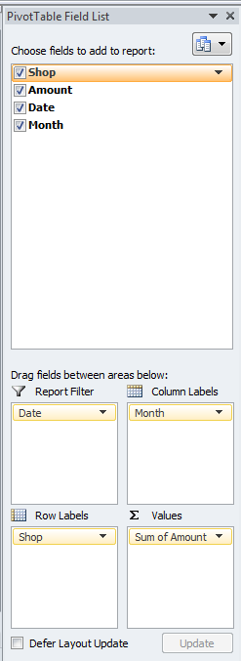

1. Click on the down arrow in the headings within the pivot table in A1 and B1. Check the Select Multiple Items box.

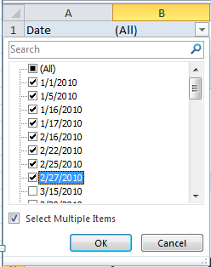

1. From the drop down box, uncheck (All) box, and then check the data that you want to be shown, and then click on OK. (All January and February)

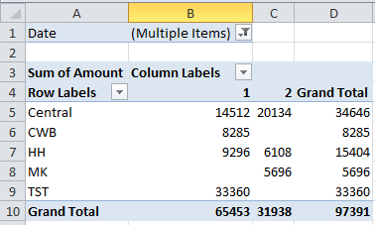

### Grouping pivot table items

Data can be summarised into higher level categories by grouping items within pivot table fields. Depending on the data in the field there are three ways to group items:

* Group selected items into specified categories.
* Automatically group numeric items
* Automatically group dates and times
* To group selected items:

Mouse

1. Select the items to group. Select adjacent items by clicking and dragging or non-adjacent items by selecting each item whilst holding [CTRL]. (select C4:E11)

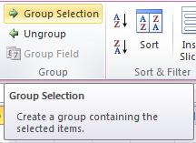

1. Choose PivotTable Tools -> Options -> Group -> Group Selection

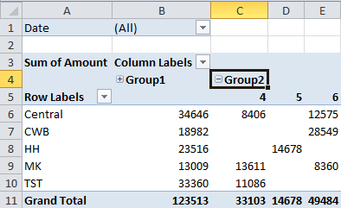

* Creating a Pivot Table Chart

Mouse

1. Select a cell within your list.
2. Choose PivotTable Tools -> Options -> Tools -> PivotChart.

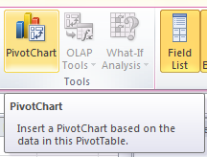

1. Choose the chart that you want. (Select Column)

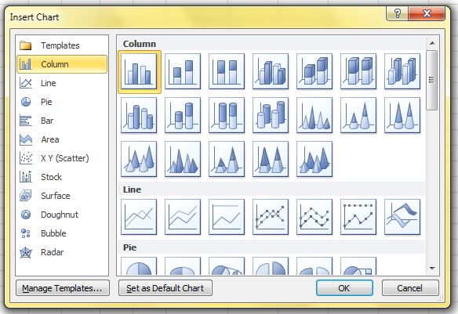

1. A chart sheet will appear displaying your Chart

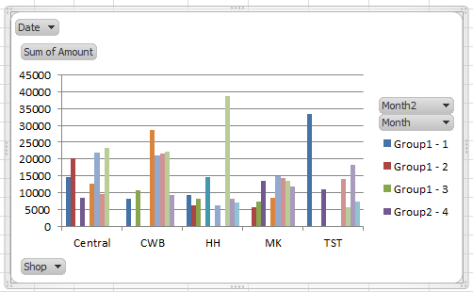

1. All of the modifying features work in the same way as a standard pivot table.

* Useful Information

If you are experiencing problems analysing list data check the following:-

* Your list is correctly set up with the first row containing the column labels identifying data in each of the columns and no blank rows between the headings and the first row of data.
* Your column headings are not ambiguous - ie they cannot be confused with function names or range names.
* Your column headings are formatted to make them stand out from the data.
* Your column headings ideally should not contain spaces - you can remove the spaces completely or replace them with an underscore (_) character.
* Your criteria range should only contain a row of headings and blank rows below. The headings must exactly match the headings at the top of your list.
* Problems sometimes occur if the criteria range looks blank but perhaps has a space in it.